Nazish Rafiq
Project
Student Management API
1-Creat Environment of API
Commands CMD:
Python –menv app_name
cd app_name
cd scripts
activate
cd..
pip install djangorestframework
django_admin startproject api
python manage.py startapp app
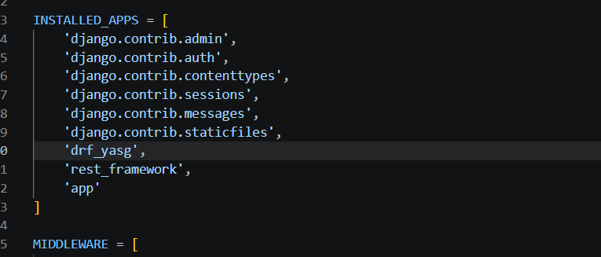
ADMIN.PY=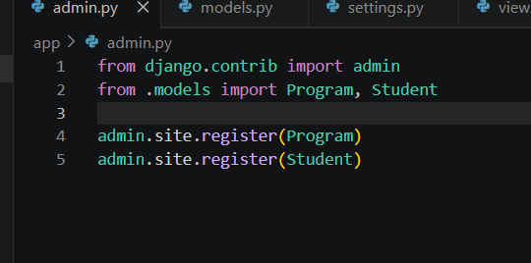
MODELS.PY=
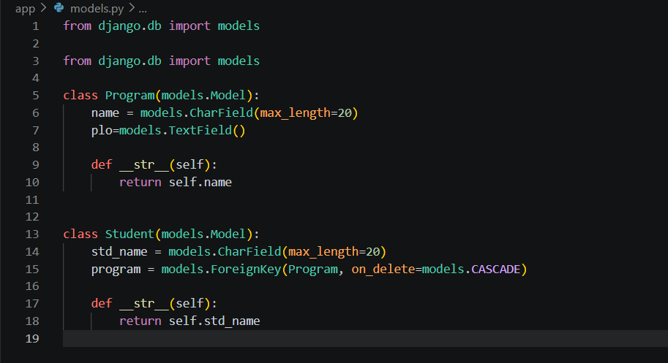
SERIALIZERS.PY=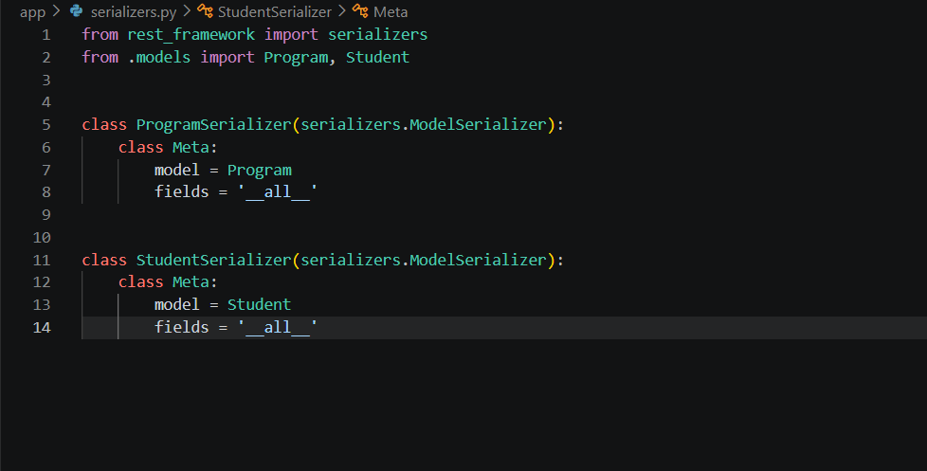
VIEWS.PY=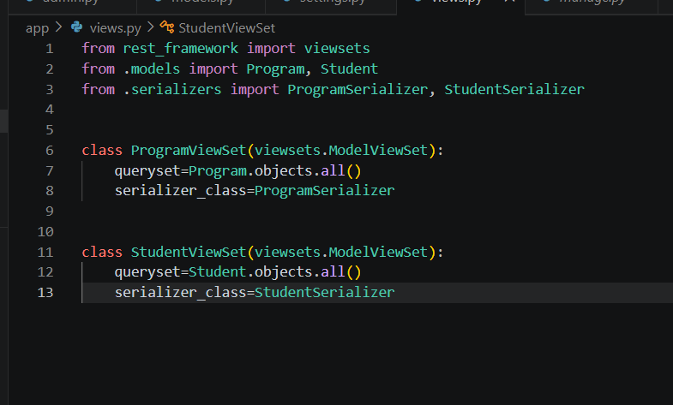
URLS.PY=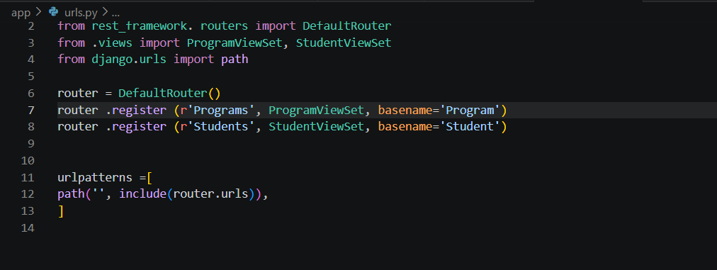
URLS main=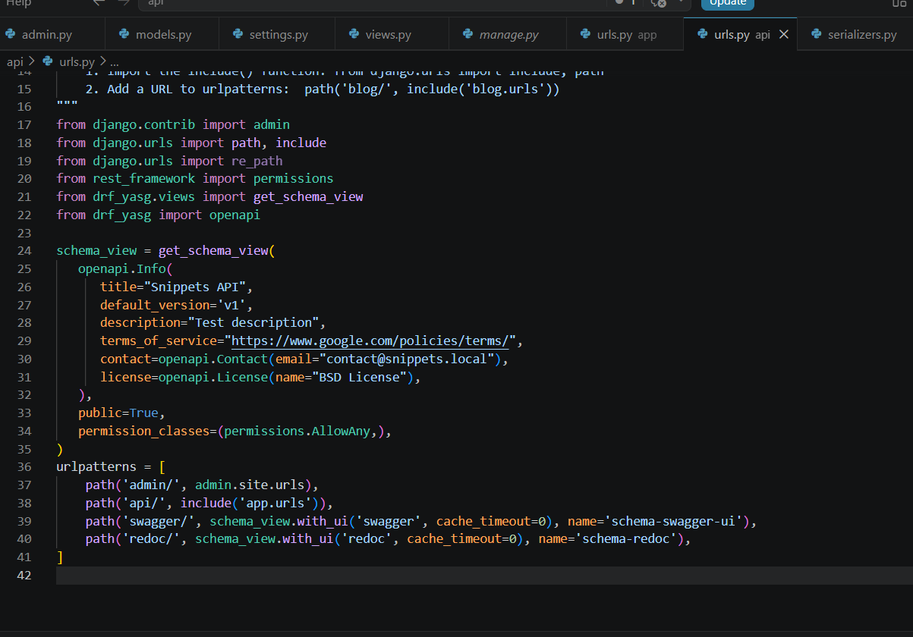
Commands
1- python manage.py makemigrations
2-python manage.py migrate
3- python manage.py createsuperuser
4-Python manage.py runserver
http://127.0.0.1:8000/ )
http://127.0.0.1:8000/api/
http://127.0.0.1:8000/admin/
http://127.0.0.1:8000/swagger/
Postman
POST & GET: 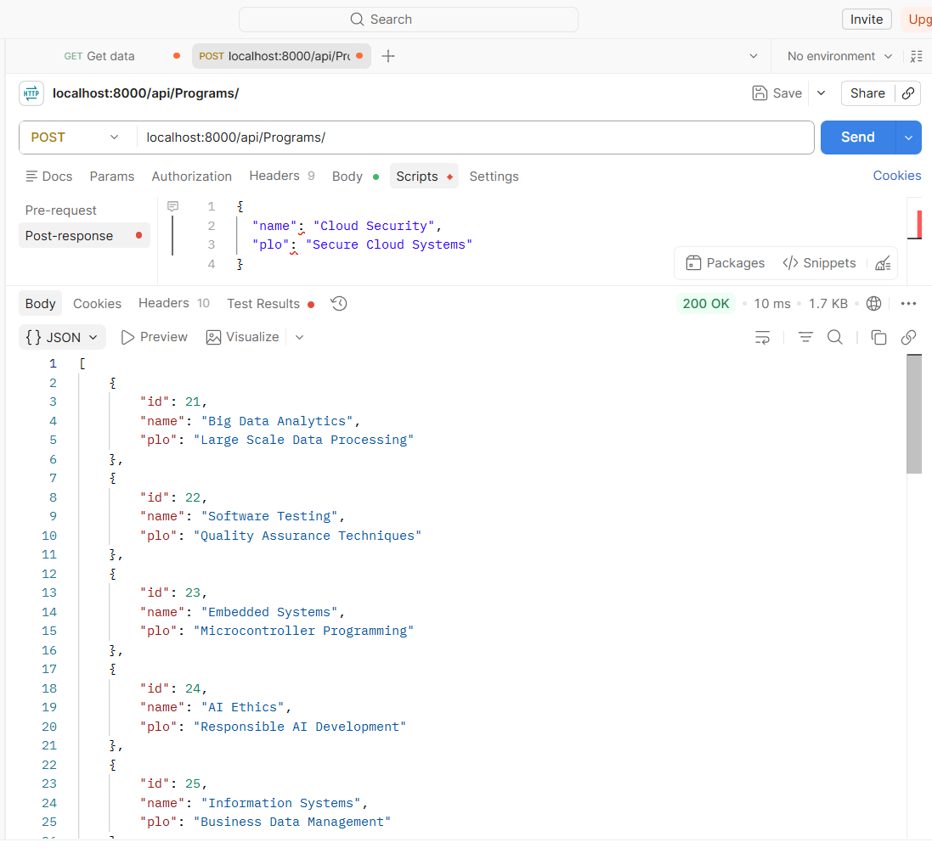 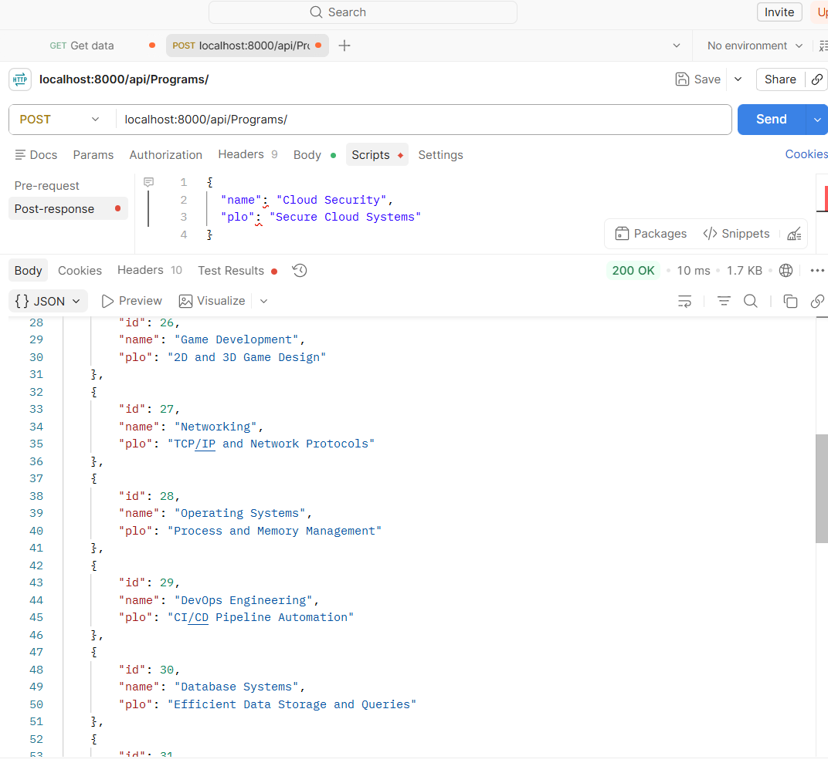
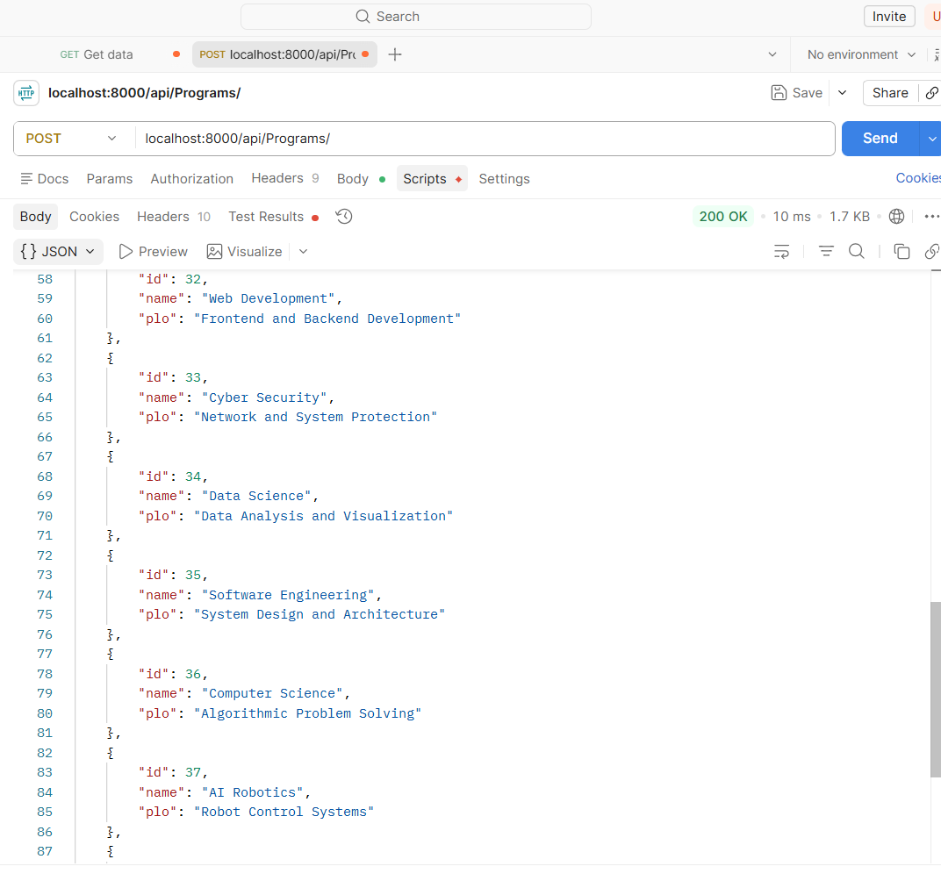
data post and get now delete data:
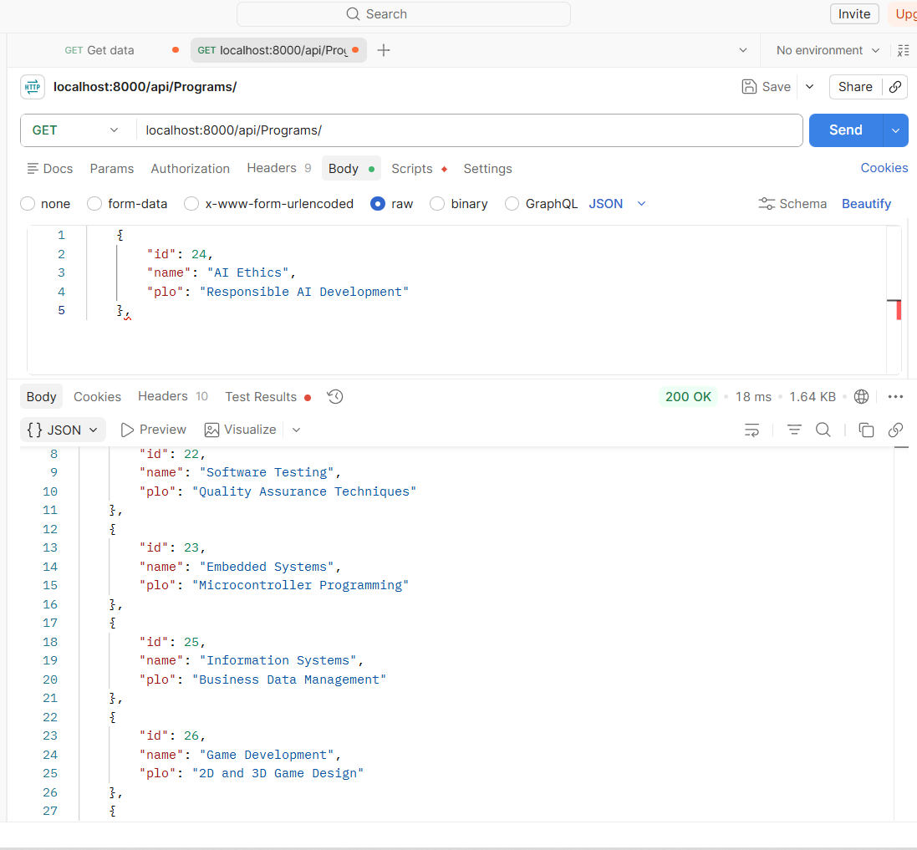
in this delete the data at id=24
now deleting the id=28 data
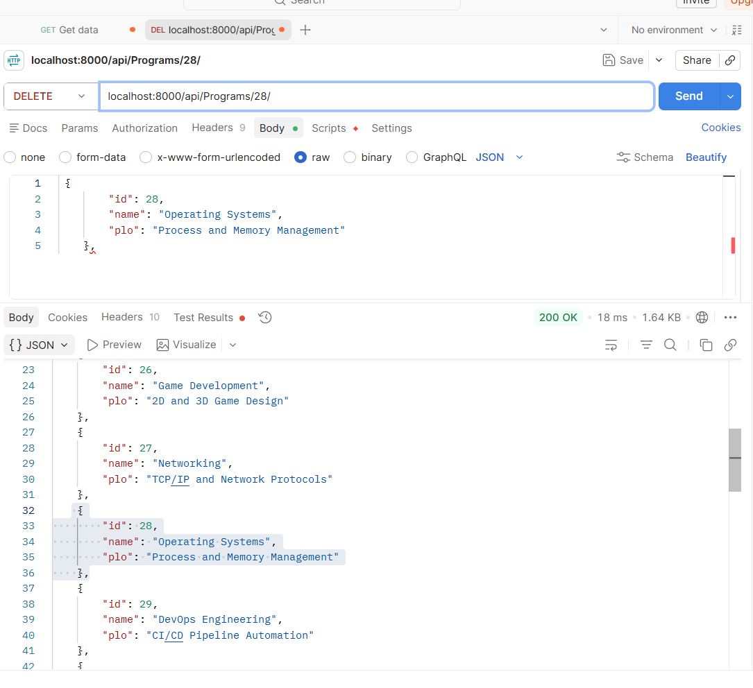
Now update data :
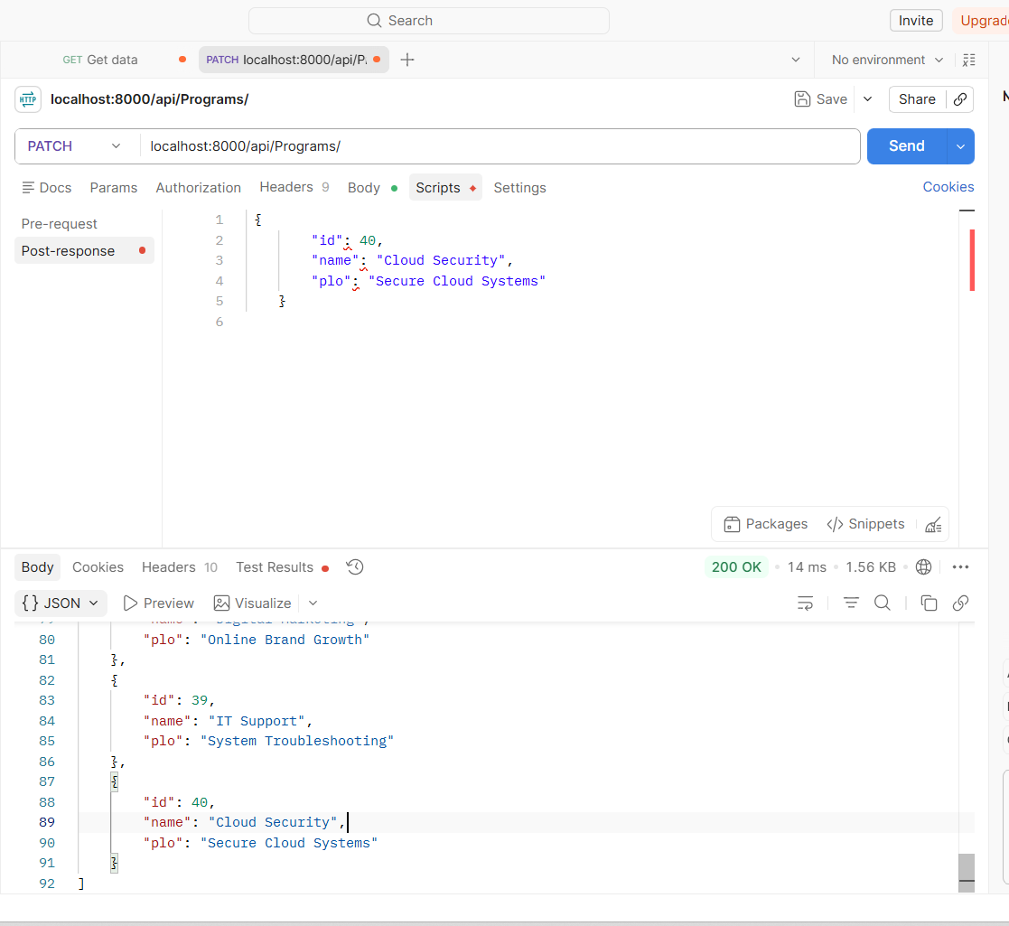
then, 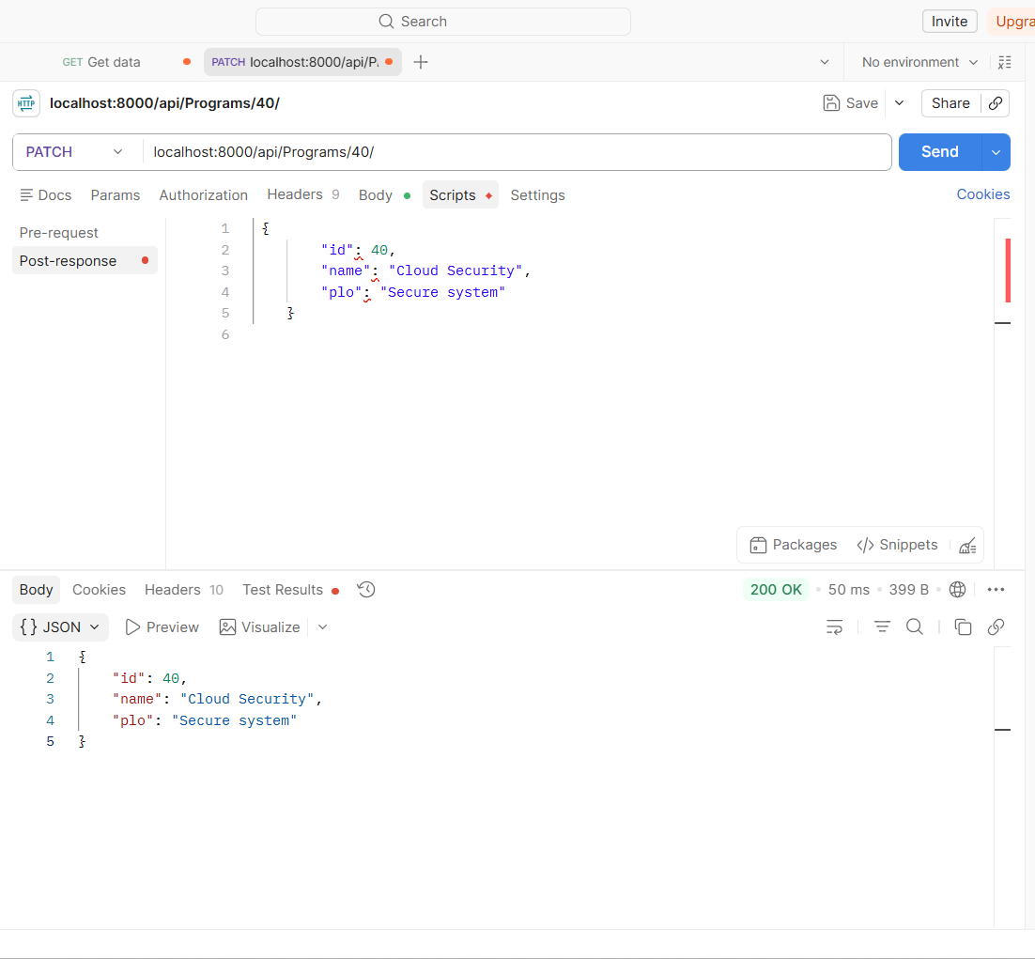
Now put data :
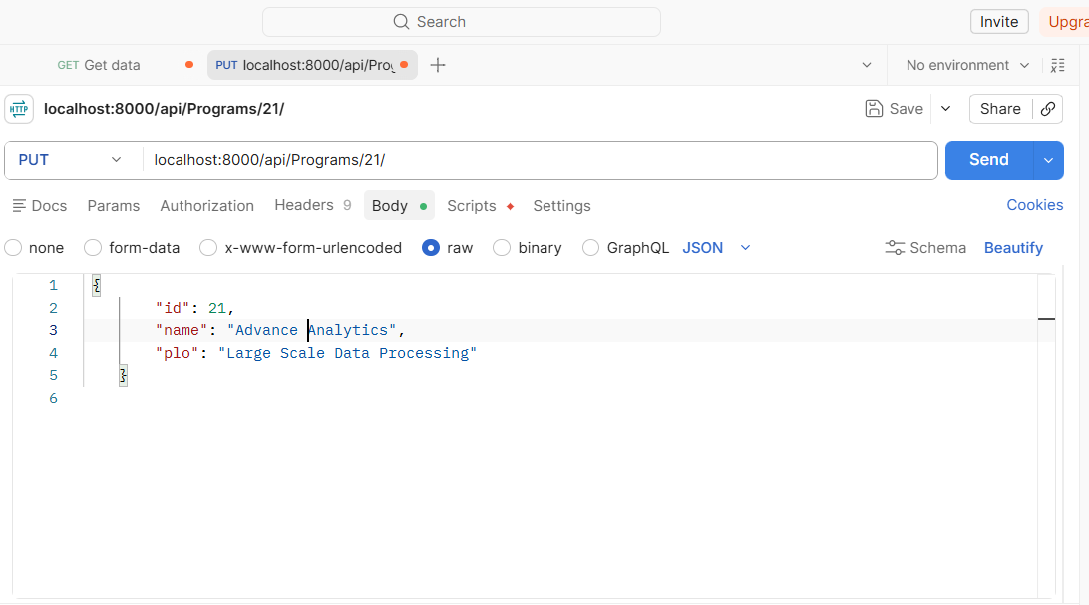
then
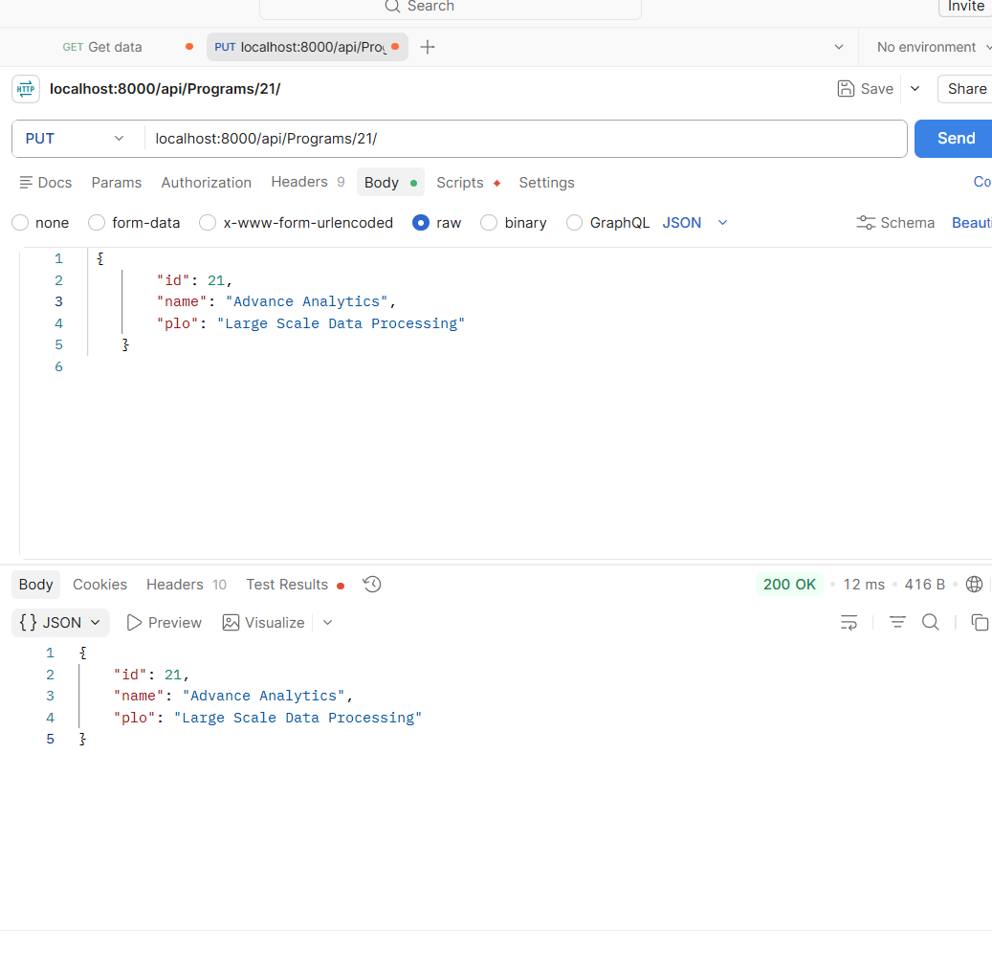
Final data after post , get , delete , patch , put
{
"id": 21,
"name": "Advance Analytics",
"plo": "Large Scale Data Processing"
},
{
"id": 22,
"name": "Software Testing",
"plo": "Quality Assurance Techniques"
},
{
"id": 23,
"name": "Embedded Systems",
"plo": "Microcontroller Programming"
},
{
"id": 25,
"name": "Information Systems",
"plo": "Business Data Management"
},
{
"id": 26,
"name": "Game Development",
"plo": "2D and 3D Game Design"
},
{
"id": 27,
"name": "Networking",
"plo": "TCP/IP and Network Protocols"
},
{
"id": 29,
"name": "DevOps Engineering",
"plo": "CI/CD Pipeline Automation"
},
{
"id": 30,
"name": "Database Systems",
"plo": "Efficient Data Storage and Queries"
},
{
"id": 31,
"name": "Cloud Computing",
"plo": "Distributed Systems and AWS"
},
{
"id": 32,
"name": "Web Development",
"plo": "Frontend and Backend Development"
},
{
"id": 33,
"name": "Cyber Security",
"plo": "Network and System Protection"
},
{
"id": 34,
"name": "Data Science",
"plo": "Data Analysis and Visualization"
},
{
"id": 35,
"name": "Software Engineering",
"plo": "System Design and Architecture"
},
{
"id": 36,
"name": "Computer Science",
"plo": "Algorithmic Problem Solving"
},
{
"id": 37,
"name": "AI Robotics",
"plo": "Robot Control Systems"
},
{
"id": 38,
"name": "Digital Marketing",
"plo": "Online Brand Growth"
},
{
"id": 39,
"name": "IT Support",
"plo": "System Troubleshooting"
},
{
"id": 40,
"name": "Cloud Security",
"plo": "Secure system"
}
]
A RESTful API for managing student records with CRUD operations using JSON data and Postman testing.
……………………………………………………………………………………

